**PIZZA SALES SQL QUERIES**



1. **Total Revenue**

SELECT sum(total_price) as Total_Revenue from pizza_sales

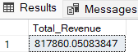

1. **Average Order Value**

SELECT sum(total_price) / COUNT(DISTINCT order_id) as Average_order_value from pizza_sales



1. **Total pizzas sold**

SELECT sum(quantity) as Total_pizza_sold from pizza_sales

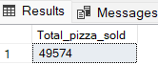

1. **Total Orders**

SELECT COUNT(DISTINCT order_id) as Total_orders from pizza_sales

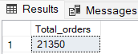

1. **Average Pizzas per order**

SELECT CAST(CAST(SUM(quantity) AS DECIMAL(10,2))/COUNT(DISTINCT order_id) AS DECIMAL(10,2)) as Average_pizzas_per_order from pizza_sales

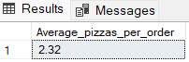



1. **Daily Trends for Total orders**

SELECT DATENAME(DW, order_date) as order_day, COUNT(DISTINCT order_id) as Total_orders

from pizza_sales

group by DATENAME(DW, order_date)

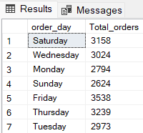

1. **Monthly Trends for Total orders**

SELECT DATENAME(MONTH, order_date) as Month_Name, COUNT(DISTINCT order_id) as Total_orders

from pizza_sales

group by DATENAME(MONTH, order_date)

order by Total_orders Desc

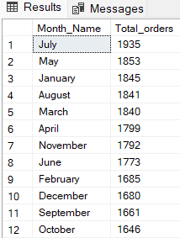

1. **% of Sales by pizza Category**

SELECT pizza_category, sum(total_price) as Total_Sales, Sum(total_price) * 100 /

(SELECT sum(total_price) from pizza_sales where MONTH(order_date) = 1) as PCT

from pizza_sales

where MONTH(order_date) = 1

group by pizza_category

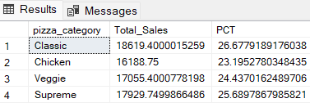

1. **% of Sales by Pizza Size**

select pizza_size, cast(sum(total_price) as decimal(10,2)) Total_Sales, CAST(sum(total_price)*100/

(select sum(total_price) from pizza_sales) AS DECIMAL(10,2)) AS PCT

from pizza_sales

group by pizza_size

order by PCT desc

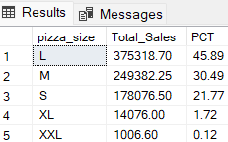

1. **Total pizza sold by pizza category**

select pizza_category, sum(quantity) as pizza_sold

from pizza_sales

group by pizza_category

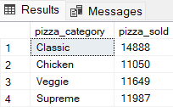

1. **Top 5 best sellers by Revenue**

select Top 5 pizza_name, sum(total_price) as Total_Revenue

from pizza_sales

group by pizza_name

order by Total_Revenue desc

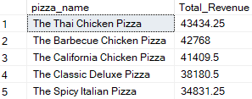

1. **Bottom 5 best sellers by Revenue**

select Top 5 pizza_name, sum(total_price) as Total_Revenue

from pizza_sales

group by pizza_name

order by Total_Revenue asc

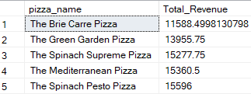

1. **Top 5 best sellers by Quantity**

select Top 5 pizza_name, sum(quantity) as Total_Quantity

from pizza_sales

group by pizza_name

order by Total_Quantity desc

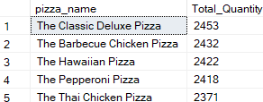

1. **Bottom 5 best sellers by Quantity**

select Top 5 pizza_name, sum(quantity) as Total_Quantity

from pizza_sales

group by pizza_name

order by Total_Quantity asc

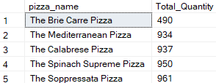

**10. Top 5 best sellers by Total Orders**

select Top 5 pizza_name, COUNT(distinct order_id) as Total_Orders

from pizza_sales

group by pizza_name

order by Total_Orders desc

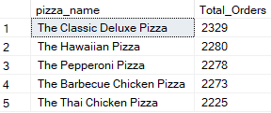

**11. Bottom 5 best sellers Total Orders**

select Top 5 pizza_name, COUNT(distinct order_id) as Total_Orders

from pizza_sales

group by pizza_name

